ANOVA

Same number of agents and type: 500 S++ in 50 iterations

With the altered aspiration model accepting after enabling memory to the algorithms.

Without modification of aspiration and no memory conveyed to the algorithms

Model: cooperation_proportion ~ C(type) + C(iteration)
Results:
sum_sq df F PR(>F)
C(type) 1.084120 1.0 152.799620 1.618083e-13
C(iteration) 0.715361 49.0 2.057662 1.756896e-02
Residual 0.219946 31.0 NaN NaN

Which means that both factors, type of data (algorithms with or without memory skills to rely on before starting a new game) and iteration are significant for understanding variability of data. The two types behave differently and values are also statisticlly different along time (iterations).

Interaction between type and iterations doesn’t work as these values tend to show colinearity, perverting the analysis.
    - Plots:
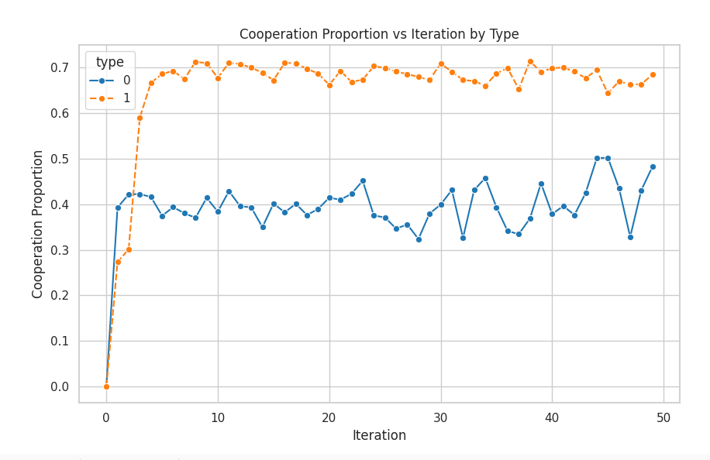

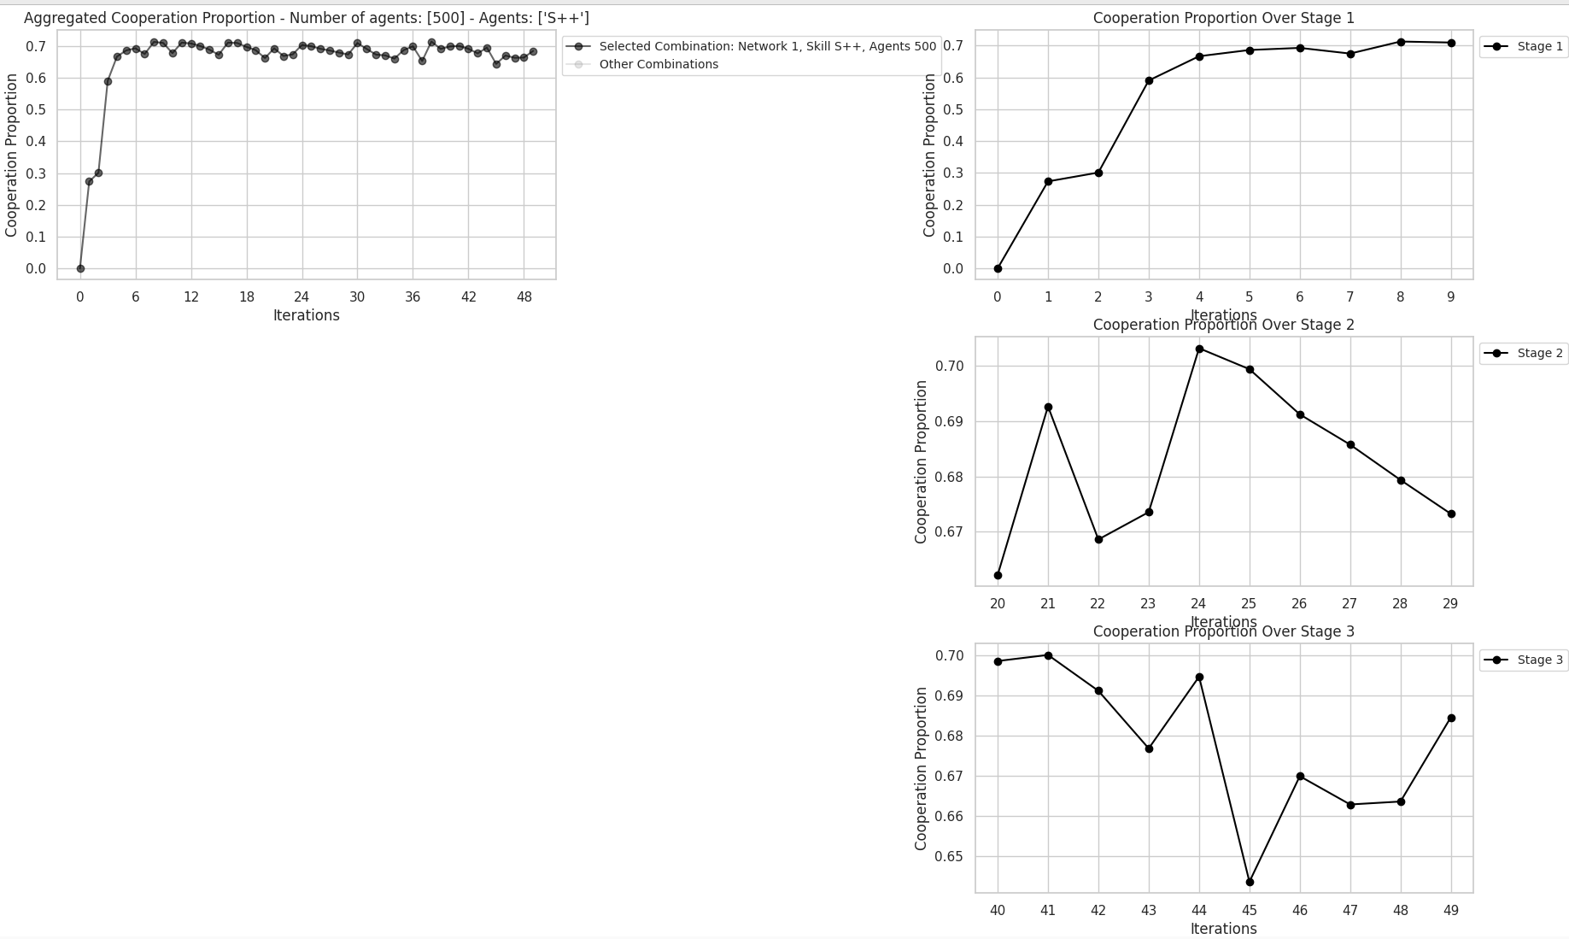

Why Use iteration as a Factor in the Two-Way ANOVA?
Including iteration as a factor in a two-way ANOVA helps to assess whether the response variable (e.g., cooperation_proportion) changes across different iterations. Here’s why and how it might make sense:
- Iteration as a Temporal Factor: If the data is collected over time or different experimental steps, iteration could reflect changes in behavior as the experiment progresses. In such a case, it's important to test whether the data evolves over time (e.g., does cooperation increase or decrease as more iterations are run?).
- Two-Way ANOVA: The purpose of a two-way ANOVA is to analyze how two factors (in this case, type and iteration) influence the dependent variable and if their interaction affects the outcome:
  - Main effect of type: Does the cooperation proportion differ between the constrained and unconstrained groups (type factor)?
  - Main effect of iteration: Does the cooperation proportion change across iterations?
  - Interaction between type and iteration: Does the effect of type on cooperation proportion vary across iterations? For example, maybe the difference in cooperation between types becomes more or less pronounced as iterations progress.
By including iteration, you are asking whether the behavior of your system changes over time (or over steps in the experiment), and if type influences this temporal change.

Example Context:
If you were running a simulation or experiment where:
- Type 1 could be a group with a specific strategy or model setting, and
- Type 0 could be a group with a different strategy or setting,
Including iteration as a factor allows you to see if:
- Cooperation levels evolve as the simulation progresses.
- The difference between the two groups changes over time (interaction effect).
This is useful in dynamic systems where you expect behavior to evolve.

Assortativity

The network does not exhibit a strong tendency for nodes of similar or dissimilar degree to connect. In other words, the degree of a node (whether it has many or few connections) doesn't play a significant role in determining which other nodes it connects with.
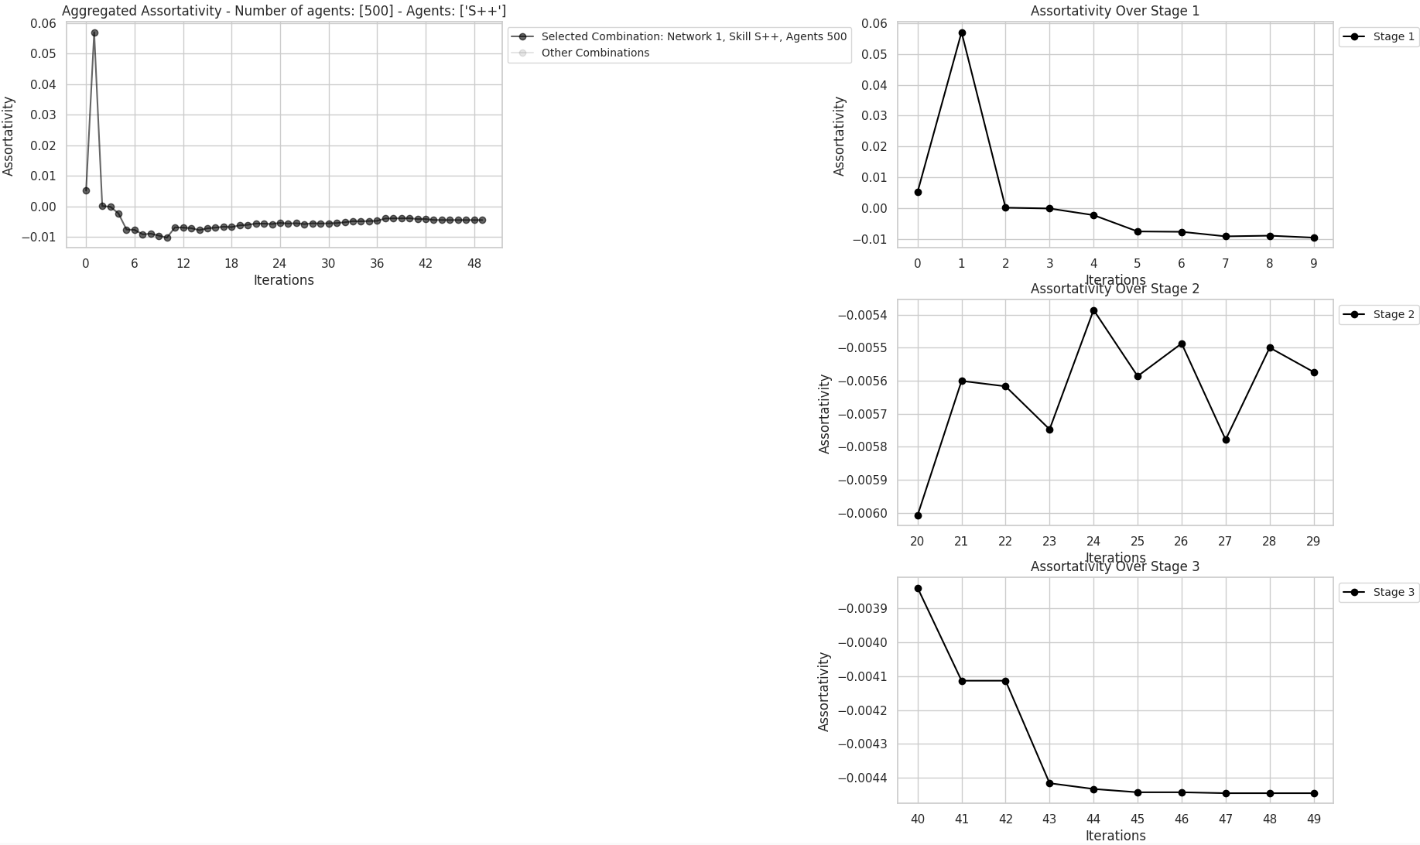

Clustering Coefficient.

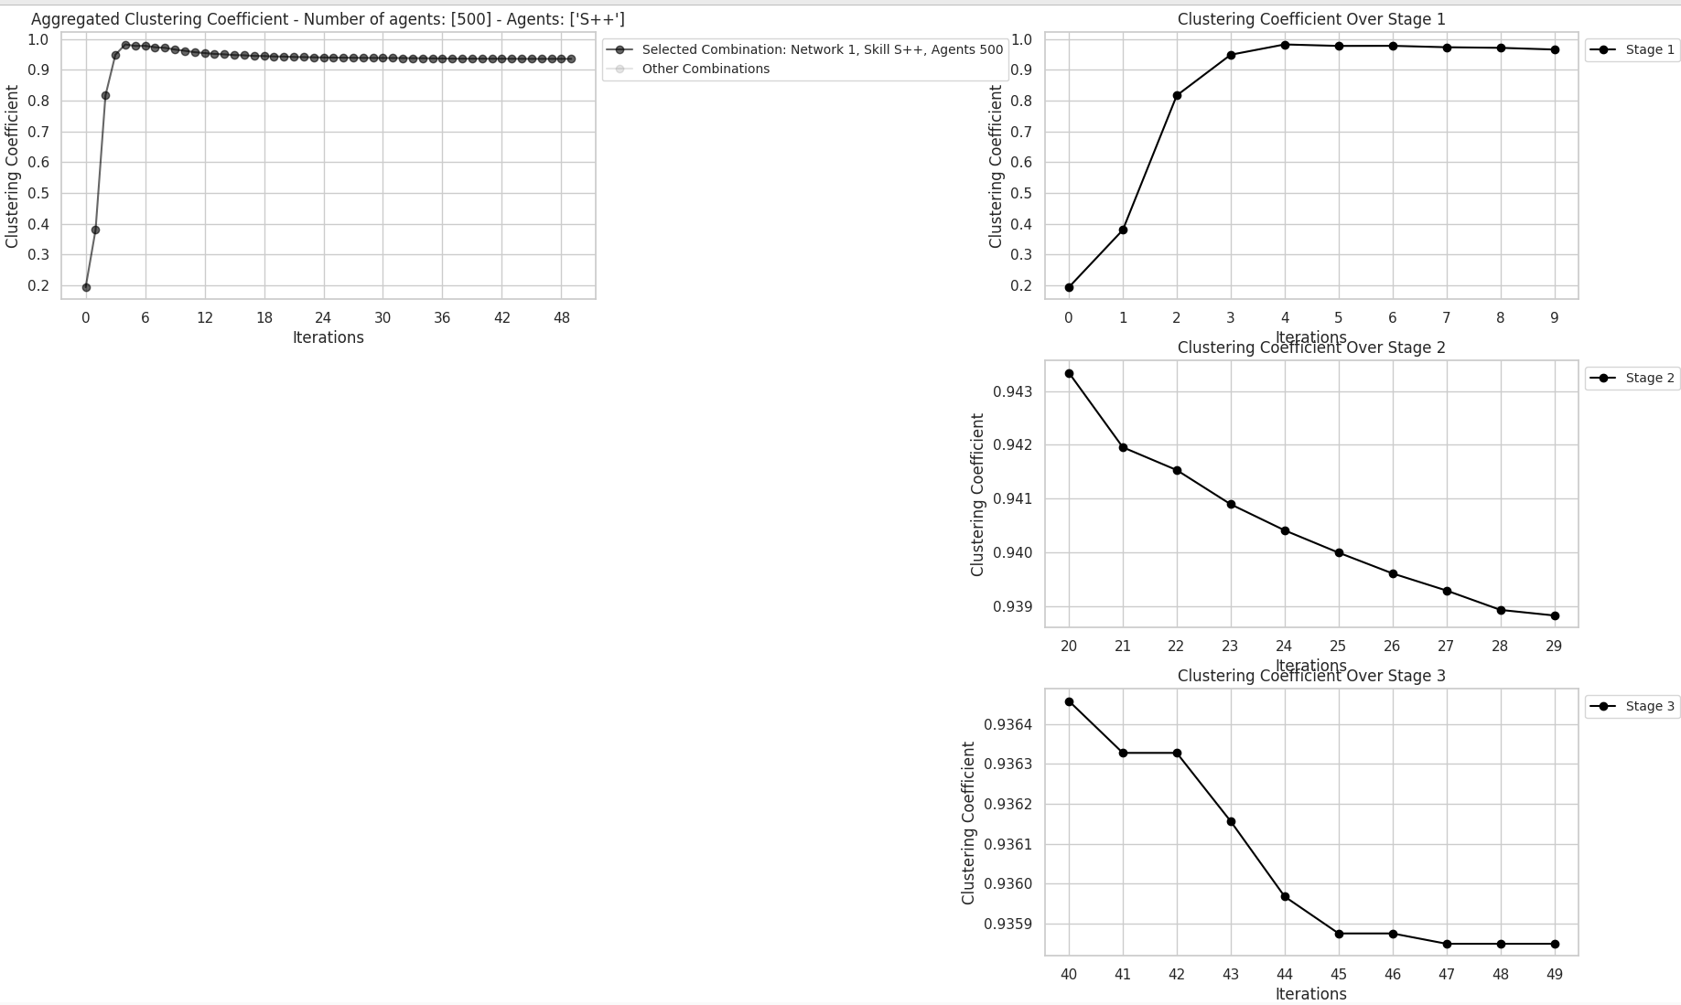

High Local Clustering:

A clustering coefficient close to 1: the nodes in the network form tightly-knit groups or clusters. If two nodes are connected to a common node, it is highly likely that they are also connected to each other.
- This suggests that the local neighborhoods of nodes are almost fully connected. The agents (nodes) tend to form dense local clusters where many triads are closed, meaning that if node A connects to nodes B and C, B and C are also connected.

Stable Network Structure:
- The fact that the clustering coefficient stabilizes at around 0.93 after the 4th or 5th iteration suggests that once clusters form, they remain stable. This means that the network does not undergo significant structural changes after the initial phase of clustering.
- The network quickly settles into a dense, clustered structure early on, and this structure persists through the remaining iterations. This could imply that interactions among agents become highly predictable or consistent over time.

To solve this points, we have these suggestions:
1. Modularity:
- Definition: Modularity is a measure of the strength of division of a network into modules or clusters. High modularity means the network is divided into tightly-knit communities with sparse connections between them.
- Interpretation: If the network has high modularity, this indicates information silos where groups of nodes interact mostly within their own clusters but rarely with nodes outside their cluster.
- Python Implementation: You can use the community package in Python to calculate modularity based on community detection algorithms like Louvain.
- High modularity (e.g., above 0.3 or 0.4) may indicate information silos, while low modularity suggests more diverse interactions across the network.
import networkx as nx import community as community_louvain # Apply Louvain algorithm to detect communities partition = community_louvain.best_partition(G) # Calculate modularity modularity = community_louvain.modularity(partition, G) print(f"Modularity of the network: {modularity}")

2. Inter-Cluster Connectivity:
- Definition: This measures how well-connected the clusters are. After detecting clusters (or communities), you can analyze the number of edges between clusters compared to within-cluster edges.
- Plot: You can visualize this by plotting the network, color-coding clusters, and drawing edges with different thicknesses to represent intra-cluster vs. inter-cluster connections.
- If the plot shows dense intra-cluster connections but few inter-cluster connections, it could indicate limited diversity in interactions.

import matplotlib.pyplot as plt
import numpy as np
# Visualize the communities
pos = nx.spring_layout(G)
colors = [partition[node] for node in G.nodes()]
plt.figure(figsize=(8, 8))
nx.draw_networkx_nodes(G, pos, node_color=colors, cmap=plt.cm.jet, node_size=50)
nx.draw_networkx_edges(G, pos, alpha=0.5)
plt.show()

3. Bridging Centrality:
- Definition: Nodes that act as bridges between different clusters have high betweenness centrality. They are crucial for information flow between different groups.
- Interpretation: If few nodes have very high betweenness centrality while others have low values, it suggests that the network may rely on few bridges to connect clusters, further indicating information silos.
- Nodes with high betweenness centrality serve as bridges between clusters. If these nodes are few, the network may have bottlenecks in information flow.
betweenness = nx.betweenness_centrality(G)
nx.set_node_attributes(G, betweenness, 'betweenness')
# Plot network highlighting nodes with high betweenness
pos = nx.spring_layout(G)
node_color = [betweenness[node] for node in G.nodes()]
nx.draw(G, pos, node_color=node_color, cmap=plt.cm.coolwarm, with_labels=True, node_size=100)
plt.show()

4. Edge Betweenness:
- Definition: Edge betweenness measures how often an edge lies on the shortest path between two nodes. Edges with high betweenness connect different communities or clusters.
- Plot: You can visualize edges with high betweenness to see which edges are crucial for inter-cluster communication.
- If only a few edges have high betweenness, it means that information flow between clusters is dependent on a few key connections, which could indicate information silos.

edge_betweenness = nx.edge_betweenness_centrality(G)
# Plot network with edge betweenness highlighting bridges between clusters
pos = nx.spring_layout(G)
edge_color = [edge_betweenness[edge] for edge in G.edges()]
nx.draw(G, pos, edge_color=edge_color, edge_cmap=plt.cm.Blues, with_labels=True, node_size=100)
plt.show()

5. Mixing Matrix (Interaction Diversity):
- Definition: The mixing matrix shows how much interaction happens within vs. between communities. A high diagonal value means most interactions are within clusters, while lower off-diagonal values suggest limited inter-cluster communication.
- A highly diagonal matrix indicates that interactions primarily happen within communities, suggesting limited diversity of interactions.
from sklearn.metrics import confusion_matrix
import seaborn as sns
# Create a confusion matrix showing interactions between communities
communities = list(partition.values())
adjacency_matrix = nx.to_numpy_matrix(G)
mixing_matrix = confusion_matrix(communities, communities, sample_weight=adjacency_matrix.flatten())
# Visualize the mixing matrix
sns.heatmap(mixing_matrix, annot=True, cmap="YlGnBu")
plt.show()

Conclusion:
- To analyze limited diversity of interactions and potential information silos in your network, the modularity and bridging centrality metrics, combined with visualizations, will be especially useful.
- A high modularity and a few key nodes or edges with high betweenness centrality could indicate strong information silos.
- Visualizing the network structure using community detection and edge centrality plots will help understand how clustered the network is and how well the clusters are connected.

Implications of High Clustering:
- Efficient communication: A highly clustered network allows for more efficient communication within local groups, as information can quickly circulate within these tightly-knit clusters.
- Limited diversity of interactions: While high clustering can make local information sharing more efficient, it can also imply limited interactions between different clusters or groups. This could create information silos, where clusters operate somewhat independently.
- Homophily or proximity-based interactions: The high clustering coefficient may indicate that agents prefer to interact with those already connected to their neighbors, possibly reflecting a preference for local interactions (proximity-based or reputation-based).
-----------------------

Time Series

1. Cumulative Sum (CUSUM) Analysis
- Purpose: Detect shifts or deviations in a time series.
- How: The function calculates a cumulative sum of deviations from the mean value. It tracks positive and negative deviations from the mean with an added threshold.
- What it does:
  - It computes two cumulative sums (one for positive deviations and one for negative).
  - Detects changes in behavior when values rise above or below a certain threshold.
  - Plots the cumulative sums to visualize significant shifts.

2. Bayesian Change Point Detection
- Purpose: Identify points in time where the statistical properties of the time series change (e.g., mean shifts).
- How: Uses the rpt.Pelt algorithm with a penalty model (l2) to find likely change points in the data.
- What it does:
  - Fits a change point detection algorithm on the data.
  - Identifies moments where a change has occurred in the data trend.
  - Visualizes the original data with vertical lines marking the change points.

3. Piecewise Regression
- Purpose: Fit linear models to segments of the data separated by predefined change points.
- How: The data is split into segments at the given change points, and a linear regression model is fitted to each segment.
- What it does:
  - Divides the data into parts based on provided change points.
  - Fits a separate linear model for each segment to observe how trends vary over time.
  - Plots the original data and the piecewise linear fits.

4. Autocorrelation Analysis
- Purpose: Analyze the degree of similarity between data points in a time series at different lags.
- How: Uses the autocorrelation function (ACF) to calculate correlations between data points at increasing time lags.
- What it does:
  - Calculates the autocorrelation of the data over different lag periods.
  - Helps identify patterns or periodicity in the data (e.g., repeated cycles or trends).
  - Plots the autocorrelation for different lag values.
Each function is designed to analyze time series data, focusing on detecting changes, trends, and periodic behavior.

